**School of Computer Science**

**UNIVERSITY OF PETROLEUM AND ENERGY STUDIES**

**DEHRADUN, UTTARAKHAND**



**Subject Name**

**Lab File**

**(2023-2024)**

**for**

**5th Semester**

|  |  |
| --- | --- |
| Submitted To:  Dr. Hitesh Kumar Sharma | Submitted By:  Ansika Saxena  500093696  B2 |

Lab Exercise 1– Install Terraform on Windows

Installing Terraform on Windows requires you to download the correct Terraform package, unpack, and execute it via the [CLI](https://phoenixnap.com/glossary/common-language-infrastructure).

# Download Terraform File for Windows

To find the latest version of Terraform for Windows:

1. Browse to the [Download Terraform](https://developer.hashicorp.com/terraform/downloads) page.
2. Select the Windows tab under the **Operating System** heading. The latest version is preselected.

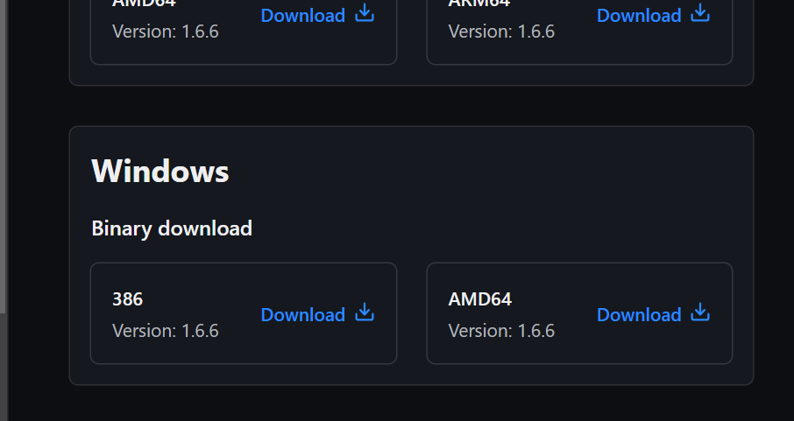

1. Choose the binary to download. Select 386 for 32-bit systems or [AMD64](https://phoenixnap.com/glossary/amd64) for 64-bit systems. Choose the download location for the zip file if the download does not start automatically.
2. Unzip the downloaded file. For example, use the *C:\terraform* path. Remember this location so you can add the path to the environment variables.

# Add Terraform Path to System Environment Variables

To add the Terraform executable to the system's global path:

1. Open the start menu, start typing *environment* and click **Edit system environment variables**. The System Properties window opens.
2. Click the **Environment Variables...** button.

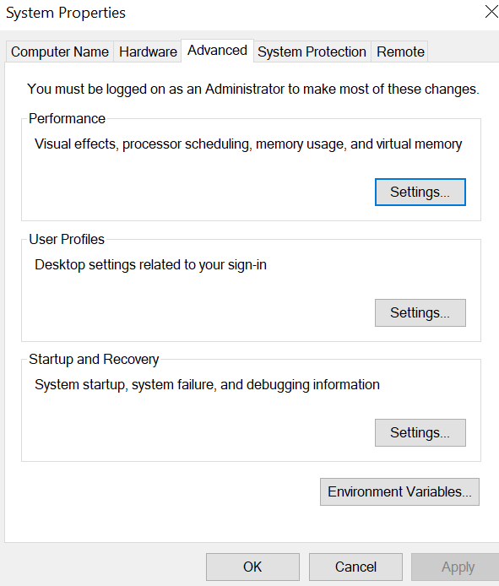

1. Select the **Path variable** in the System variables section to add terraform for all accounts. Alternatively, select **Path** in the **User variables** section to add terraform for the currently logged-in user only. Click **Edit** once you select a Path**.**

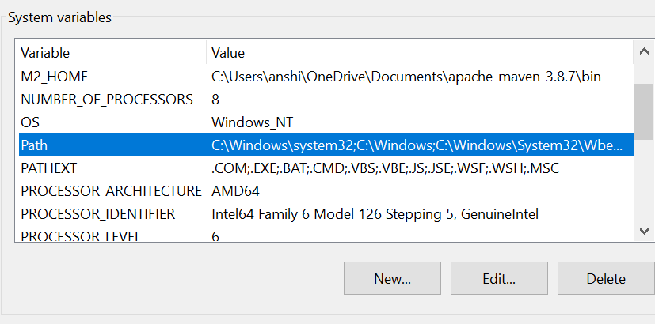

1. Click **New** in the edit window and enter the location of the Terraform folder.

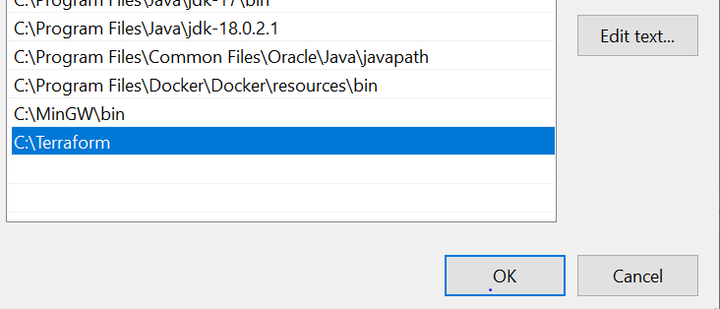

1. Click **OK** on all windows to apply the changes.

# Verify Windows Terraform Installation

To check the Terraform global path configuration:

1. Open a new command-prompt window.
2. Enter the command to check the Terraform version: terraform –version.

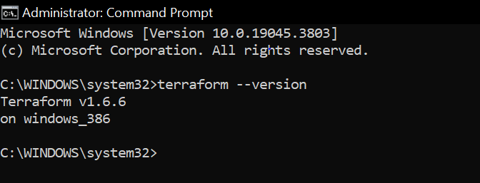

The output shows the Terraform version you downloaded and installed on your Windows machine.